Menu

Important Times/Dates:
- Recurring weekly :
- Meeting (With Supervisor): Wednesday 12:00 pm ~ 12:45pm
- Meeting (Team only): Tuesday 11:00 am ~ 12:00 pm
- Meeting (With client): Thursday 5:00 pm ~ 6:00pm (Temporary for Jan 22nd)

Full class meetings (8:30-11:30am, LH4096):
- • January 8th : Introduction to MGTA621
- • January 22nd : Team resumé and team charter (presented by career center)
- • January 29th : Introduction to Project Management
- • February 12th : Midterm internal presentations to MMA faculty panel
o Presentation slides should be submitted to faculty advisor by Feb 10th
- • April 2nd : Final internal presentations to MMA faculty panel
o Presentation slides and draft report should be submitted to faculty advisor by March 31st

Milestones:
- • Week of January 22nd : Client meeting(Thursday 5:00 pm ~ 6:00 pm (Temporary for Jan 22nd) ), Project kickoff
- • Week of February 23rd -27th : Client meeting, Midterm Presentation
- • Week of April 13th -17th : Client meeting, Final Presentation

Deadlines:
- • January 12th : Signed NDAs
- • February 10th: Submit Midterm internal presentation slides to faculty advisor
- • February 12th : MMA consulting agreement and statement of work
- • March 31st: Submit Final internal presentation slides to faculty advisor
- • April 17th : Final report

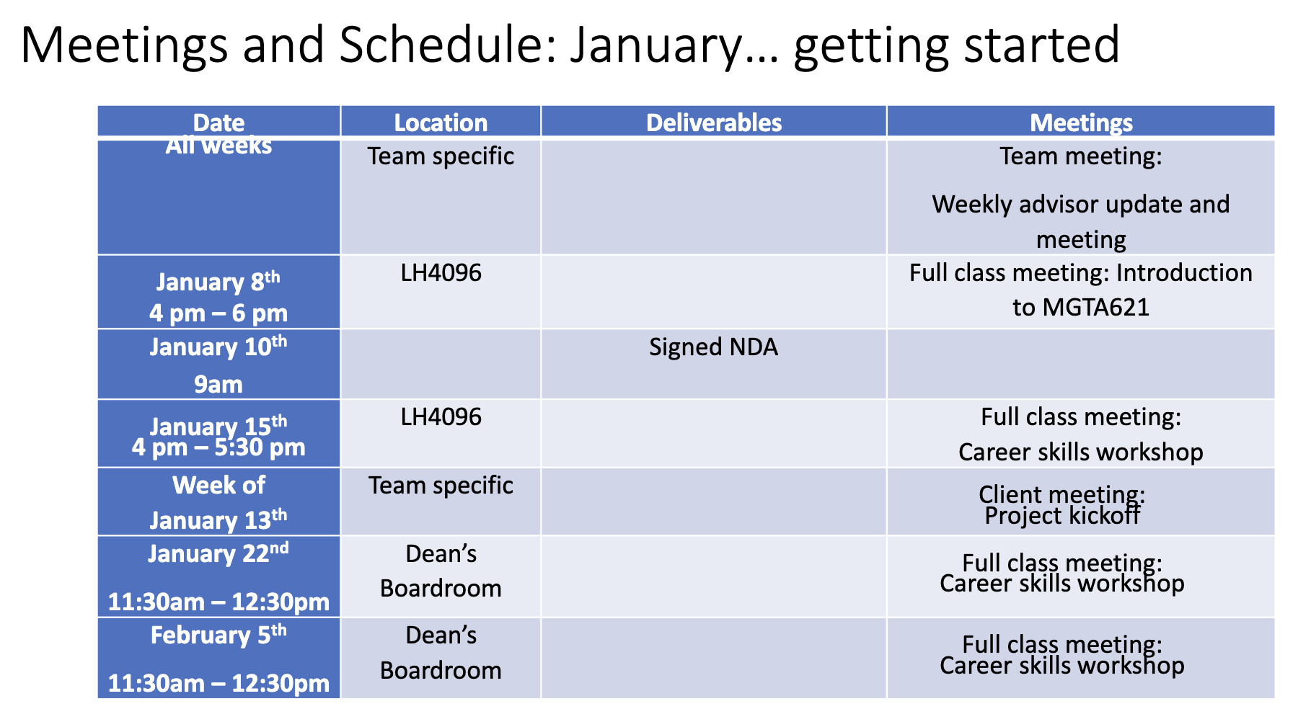
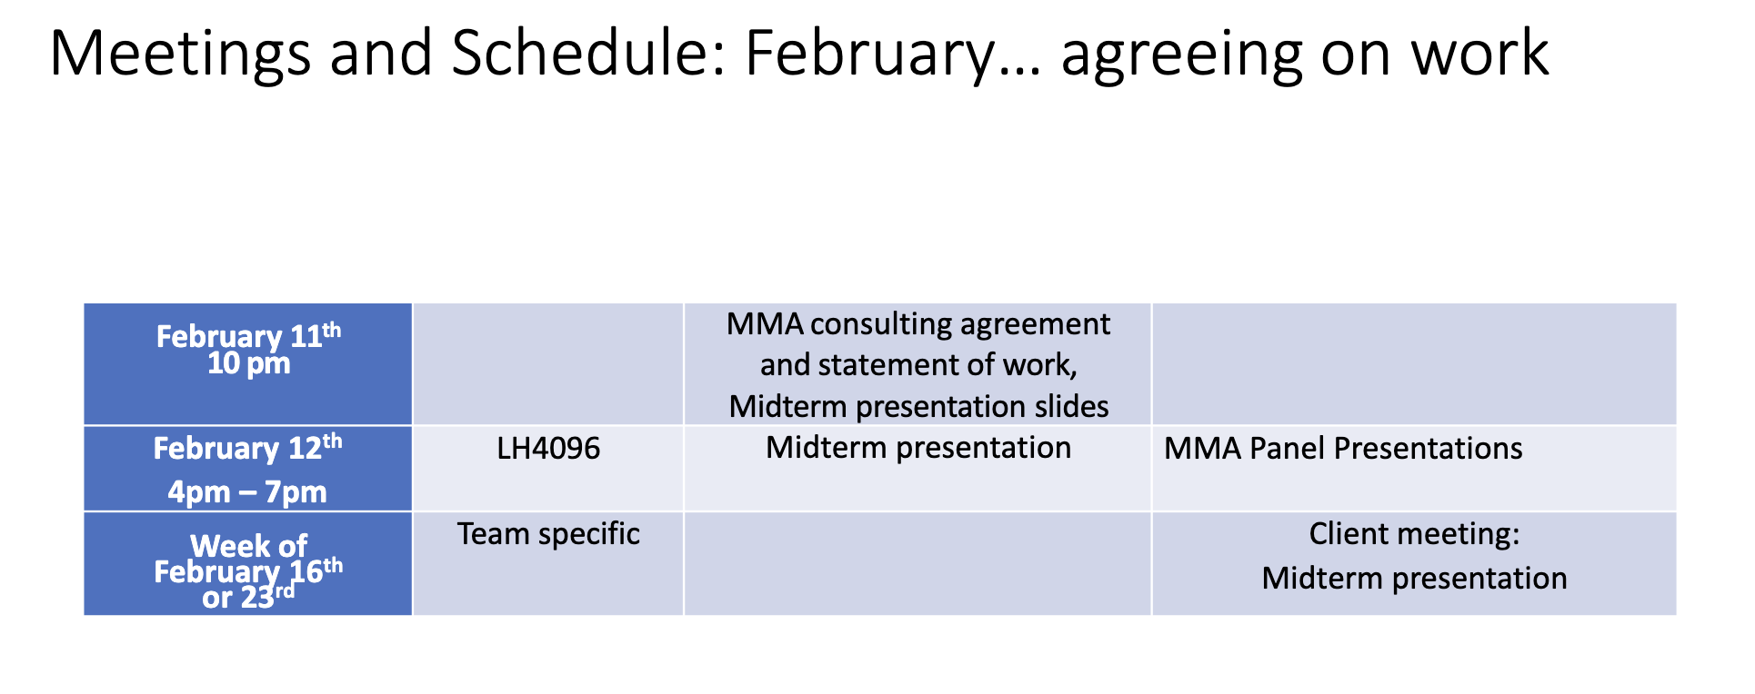
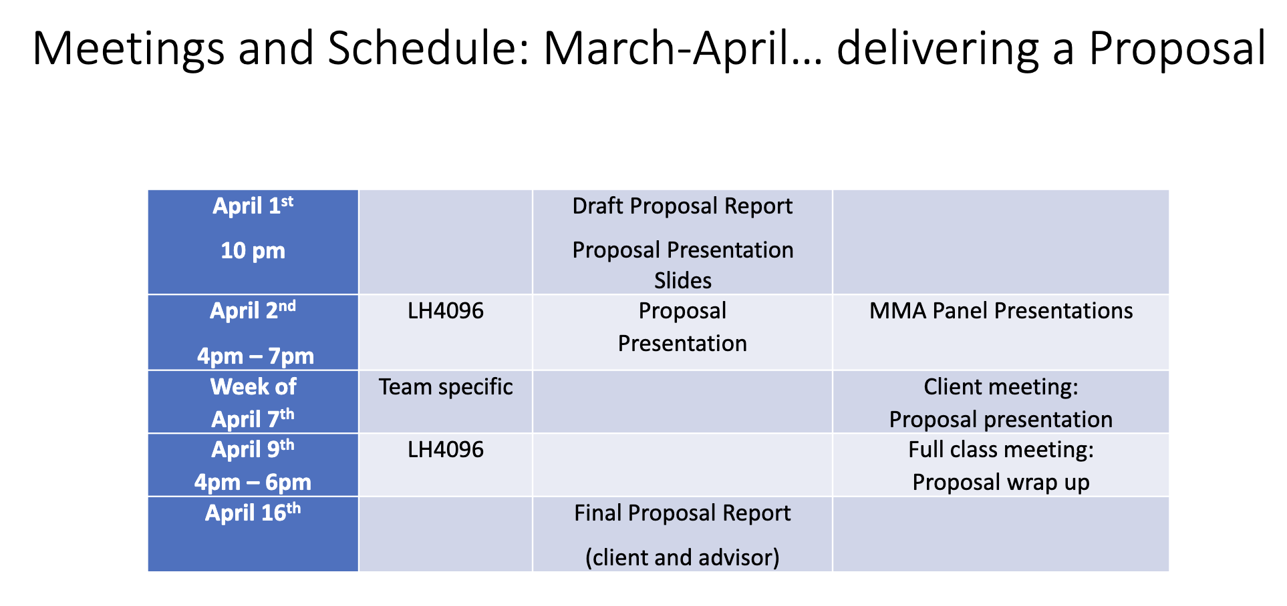

Duty allocation:

- Project Manager: Amreen, Shuyue

- Contact with client: Jiahua(David)

- Note taking: Shuyue, Amreen,Yue Wang(Nikita)

- Technical: Mohammed

